Results (Draft)

3. Results

All the results when in linear models were not significant-statistical tables complementing visualizations to demonstrate complexity

3.1 Sediment Deposition Across Ramped and Scarped Marsh Edges

a. Basic Aggregation of Ramped vs. Scarped Sites (Visualizations and Statistical Table)
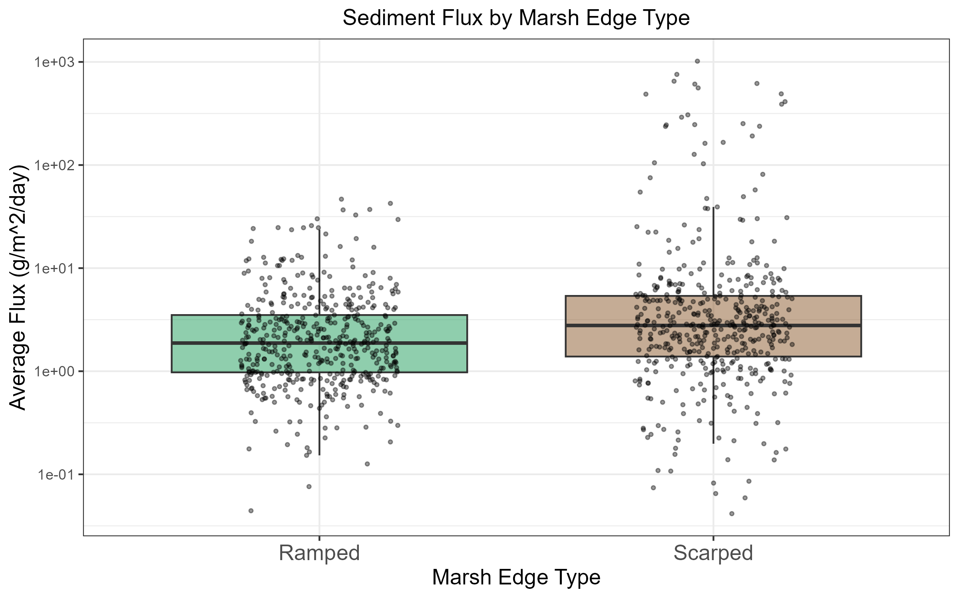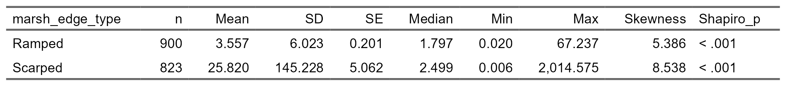

b. Site Level Detail-Color Coded still with Ramped vs. Scarped Sites (Visualizations and Statistical Table)
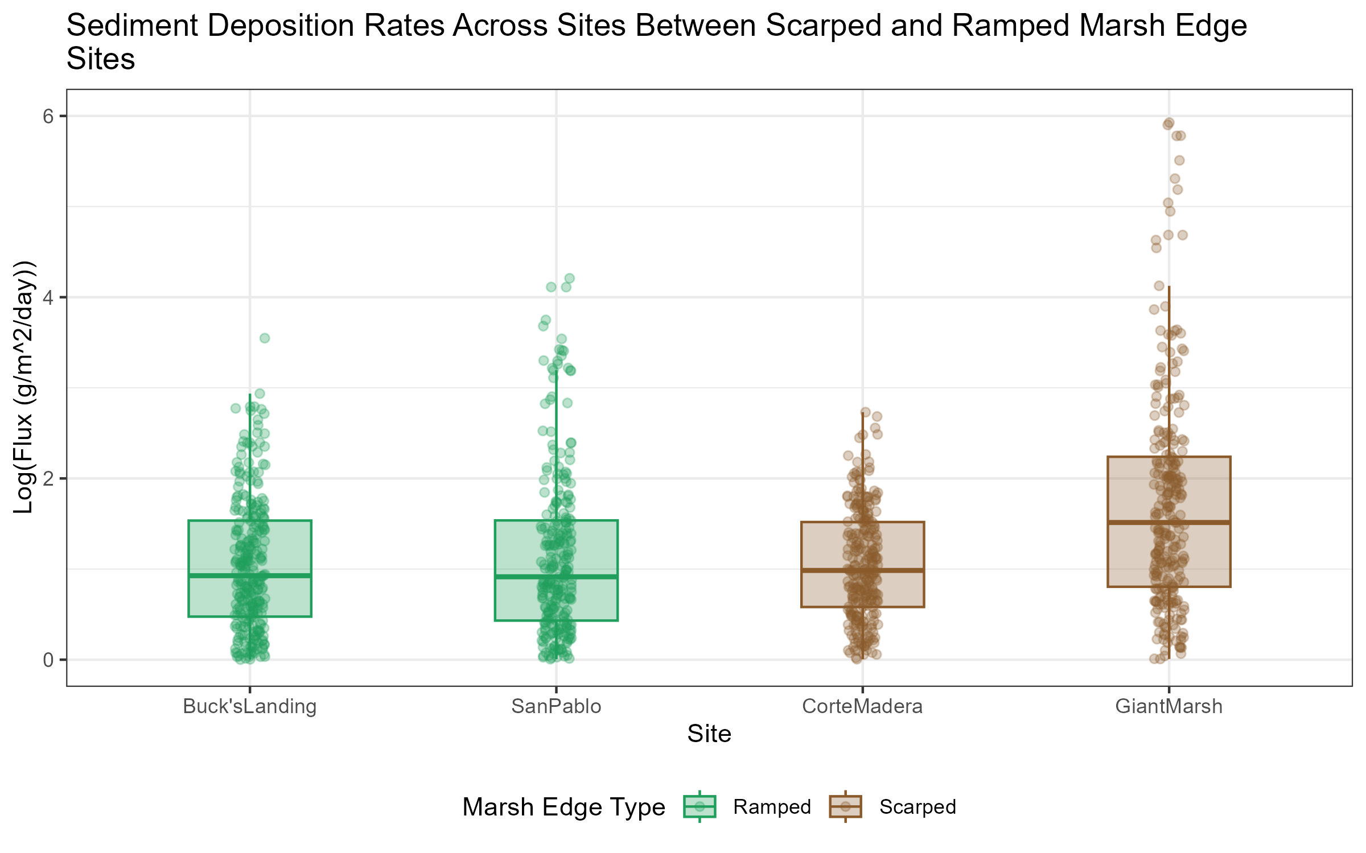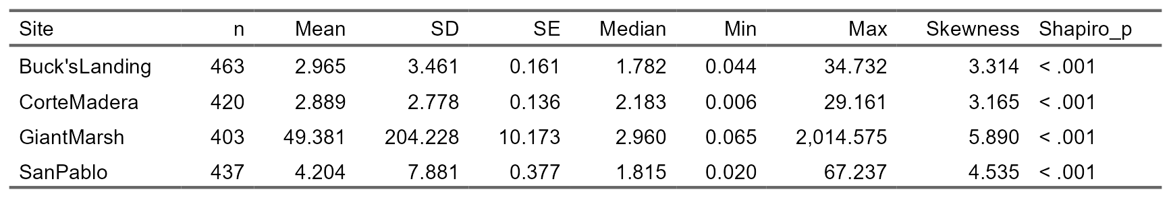

c. Within Site Level Differences of z* and Distance (Visualizations and Statistical Table)
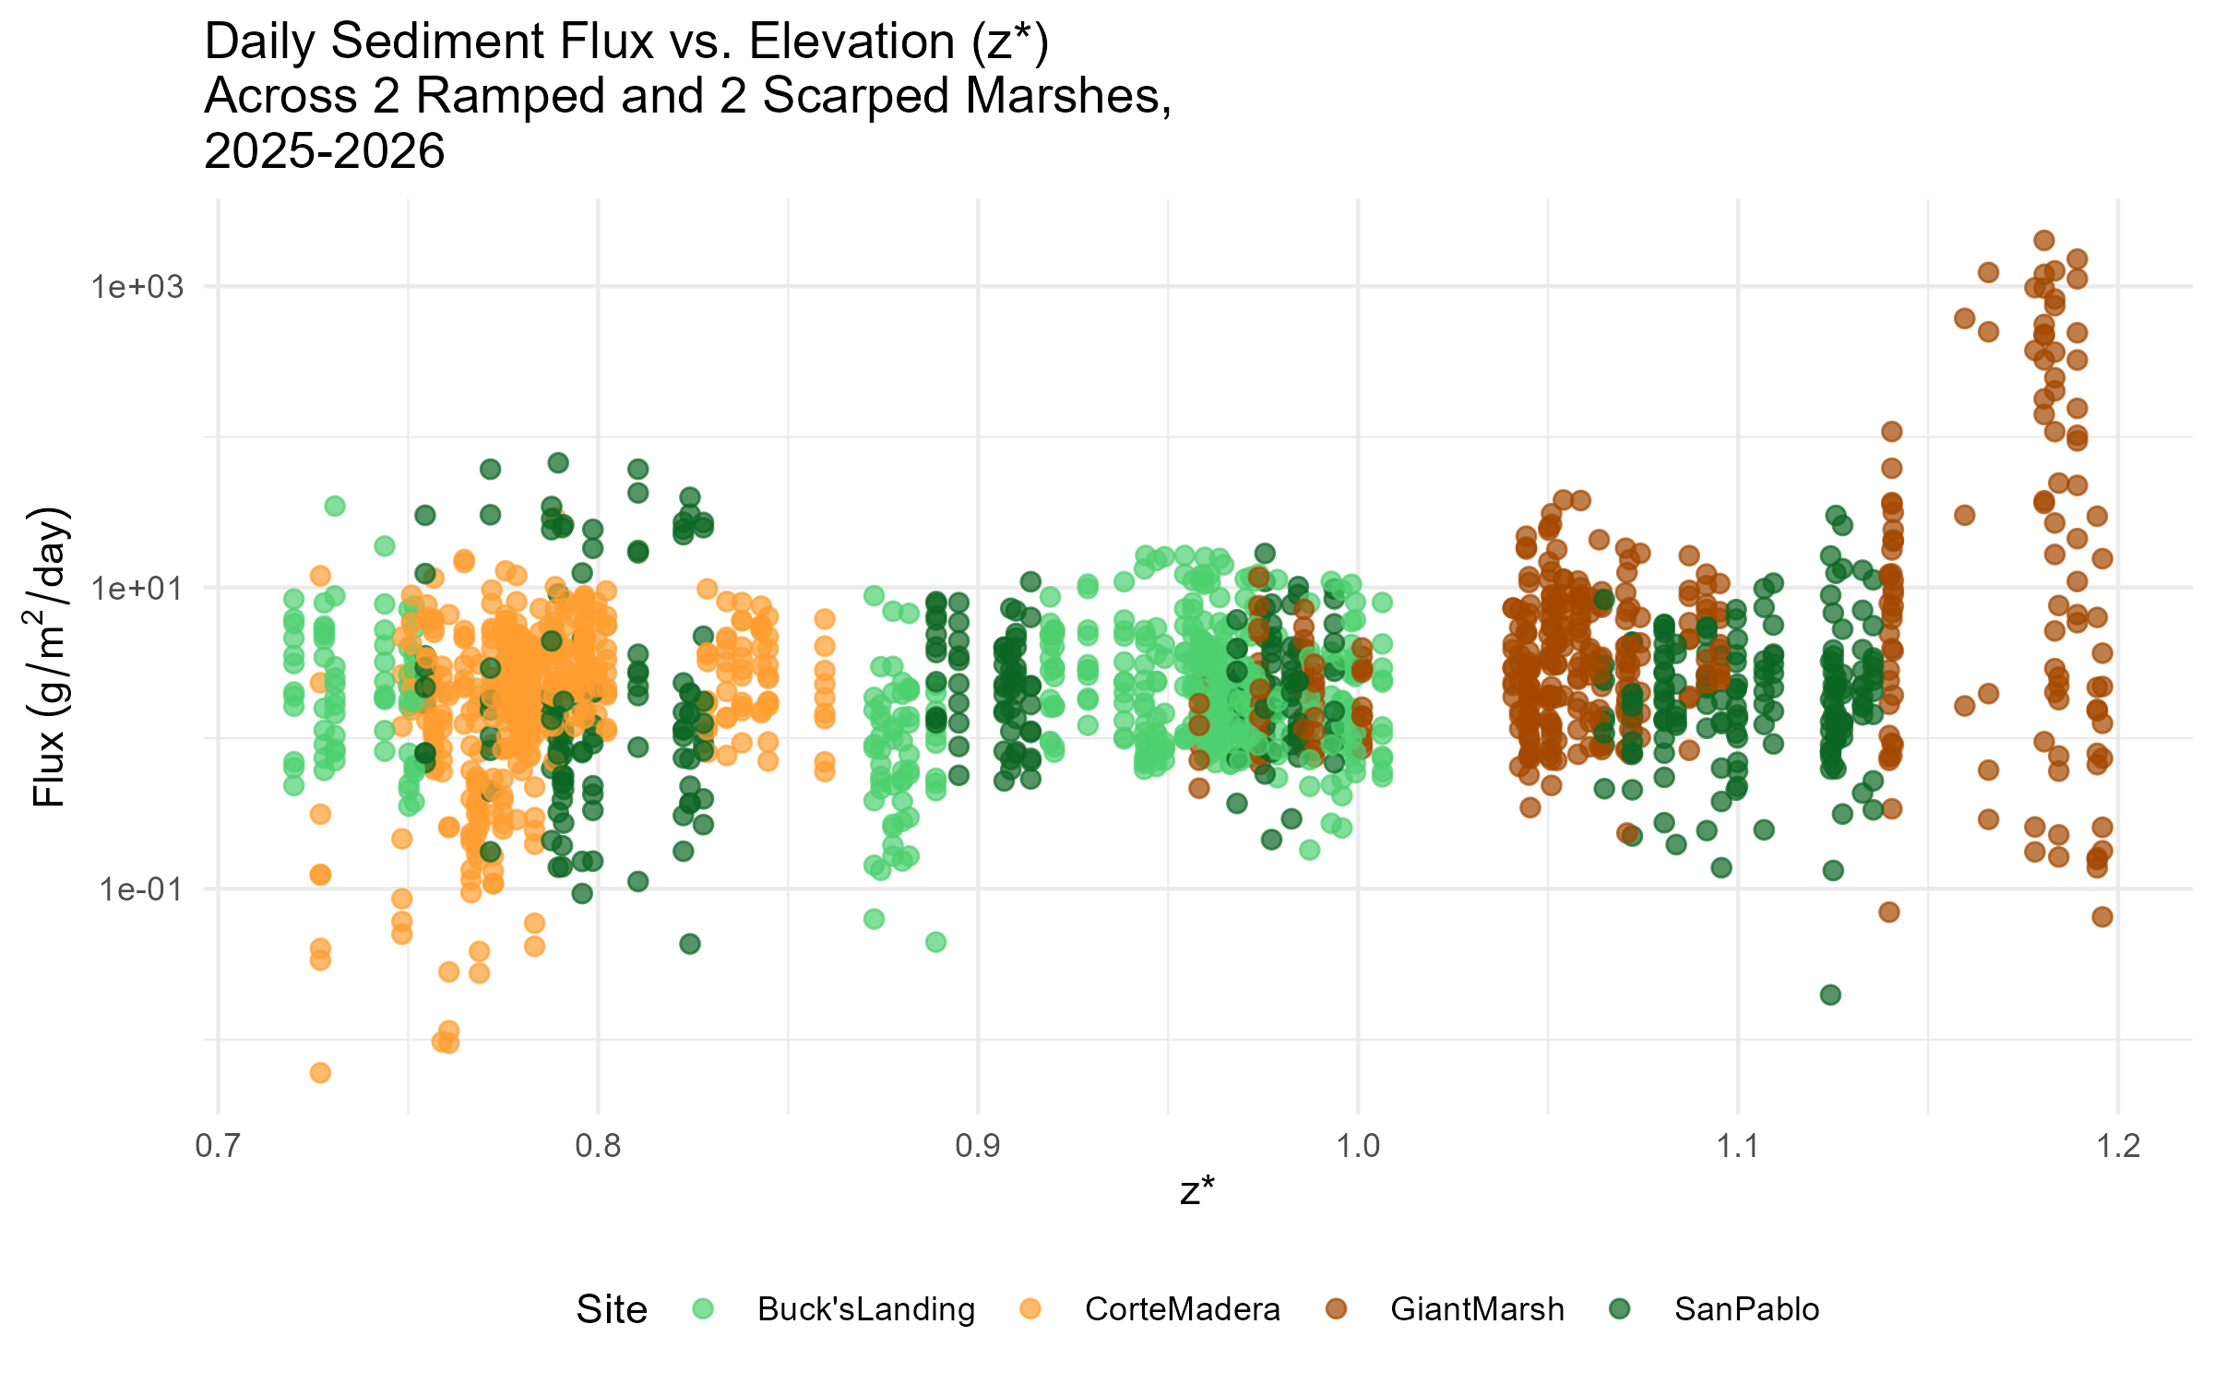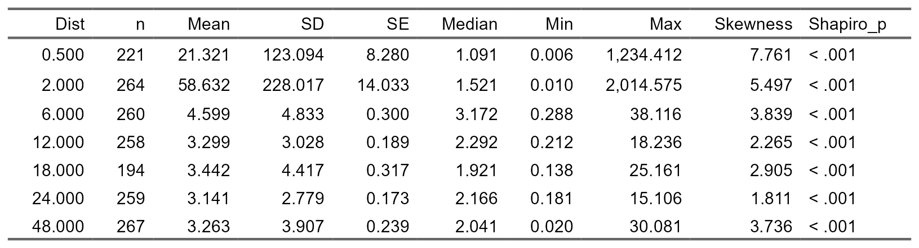

d. Within Site Level Differences Between Months Throughout the Year (Visualizations and Statistical Table)
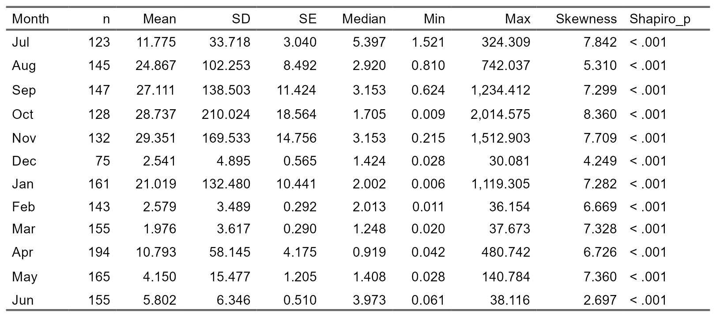

3.2 Sediment Deposition Rates Across Years in One Ramped and One Scarped Edge Marsh

a. Basic Aggregation of 2022-2023 vs. 2025-2026 comparison (Visualizations and Statistical Table)
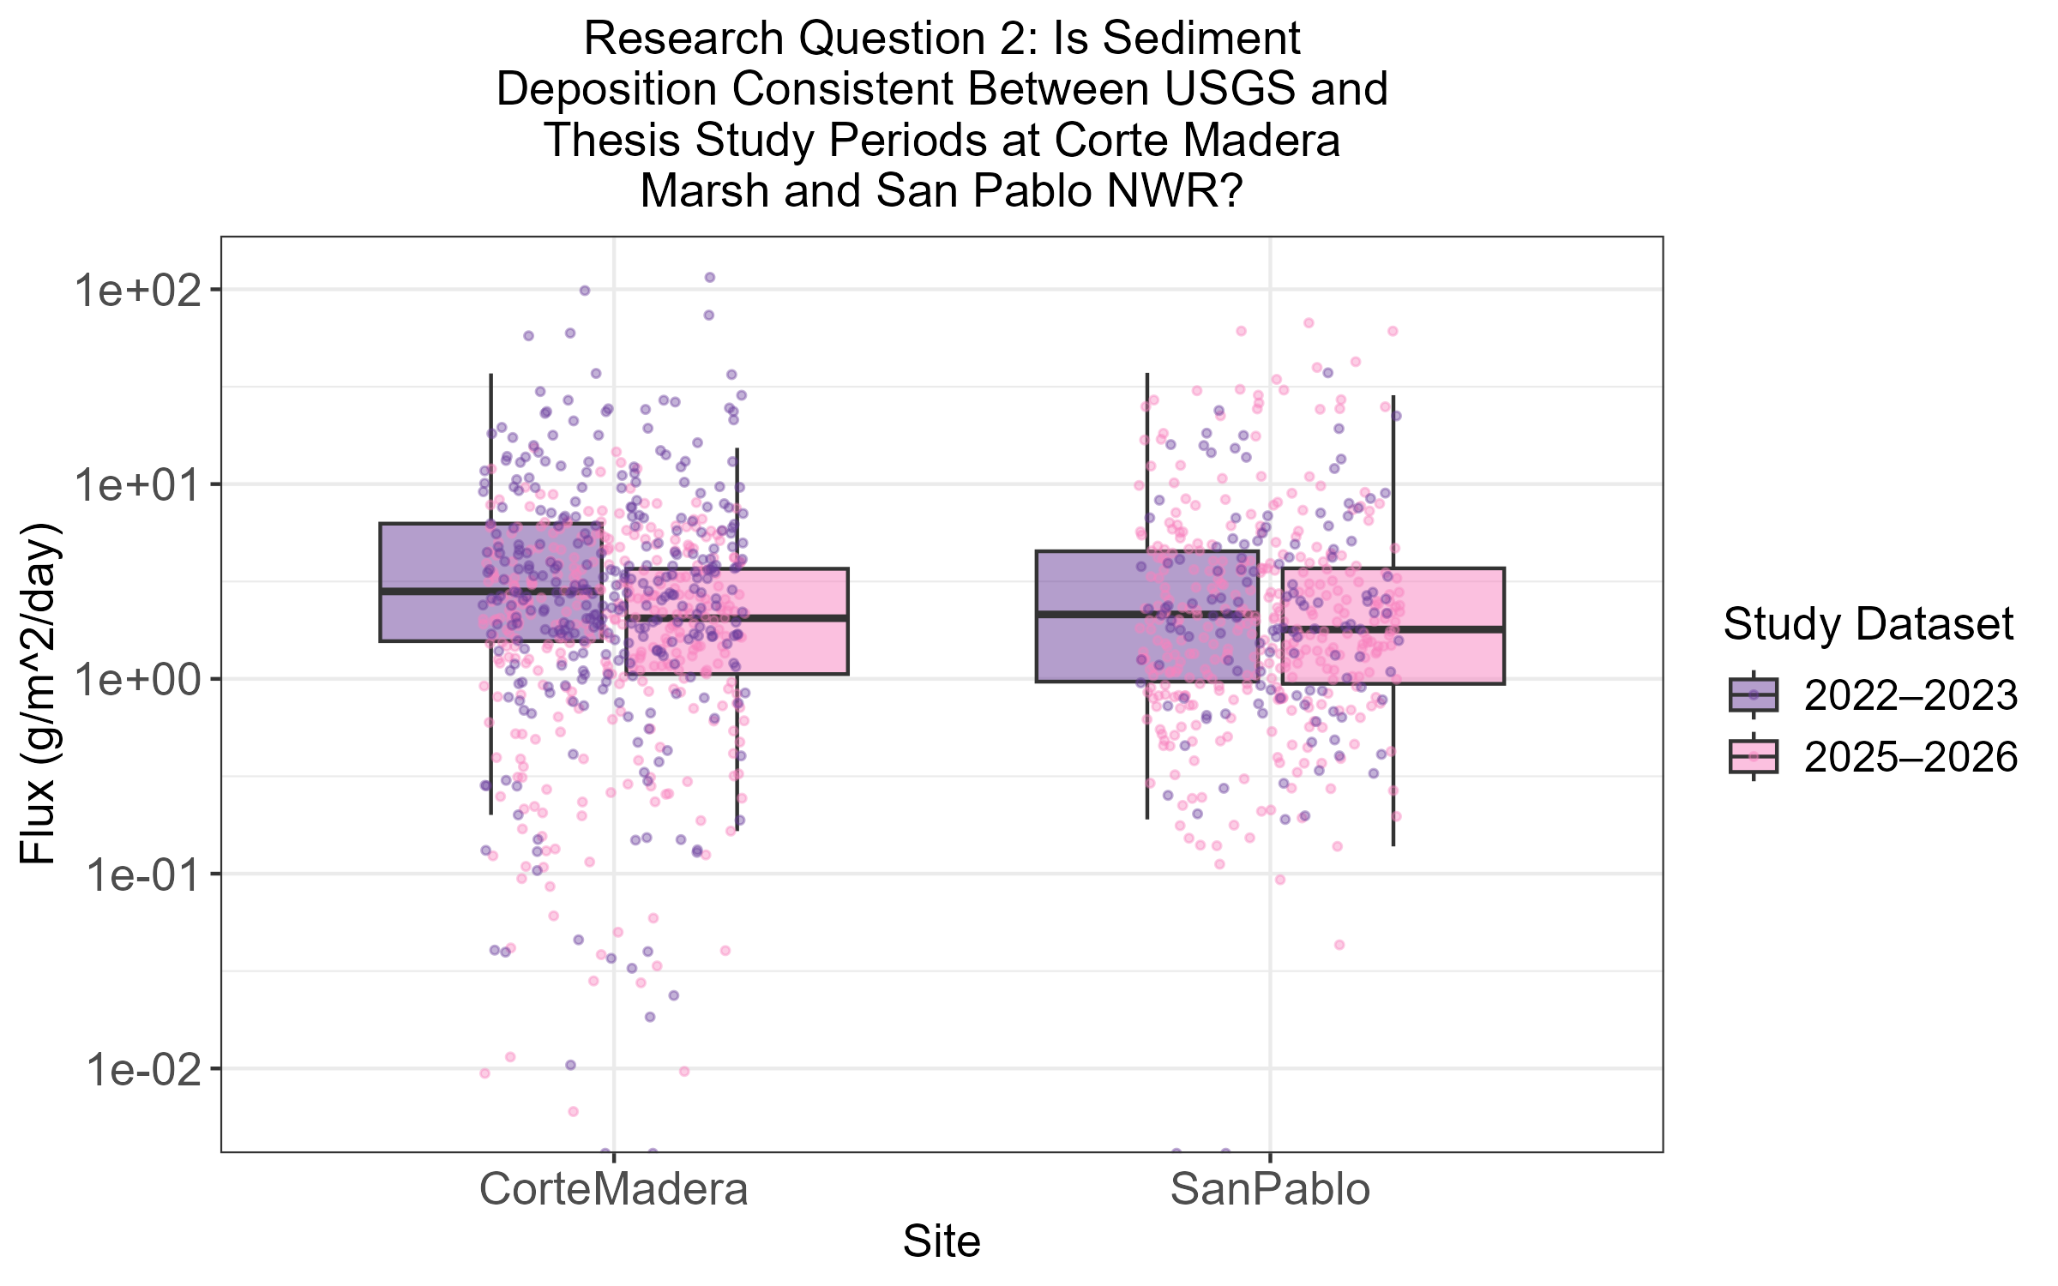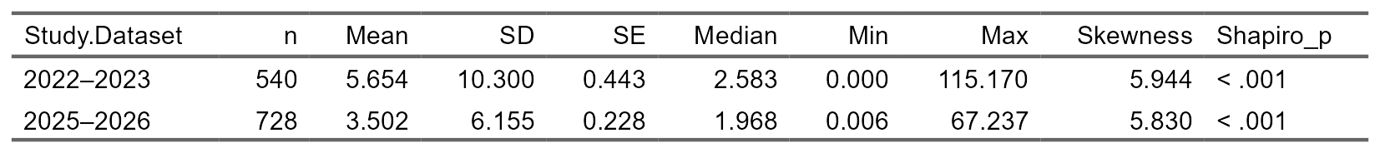

b. Site Comparison of San Pablo and Corte Madera through 2022-2023 vs. 2025-2026 (Visualizations and Statistical Table)
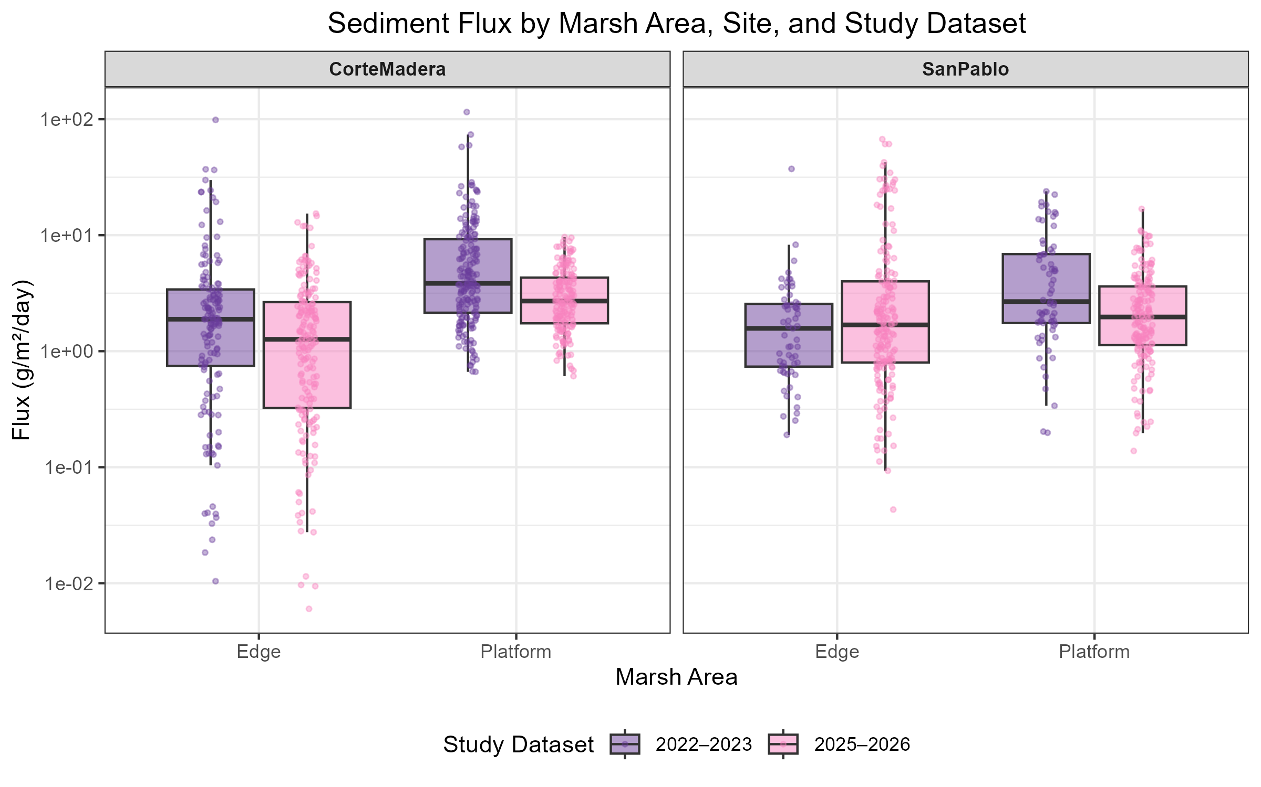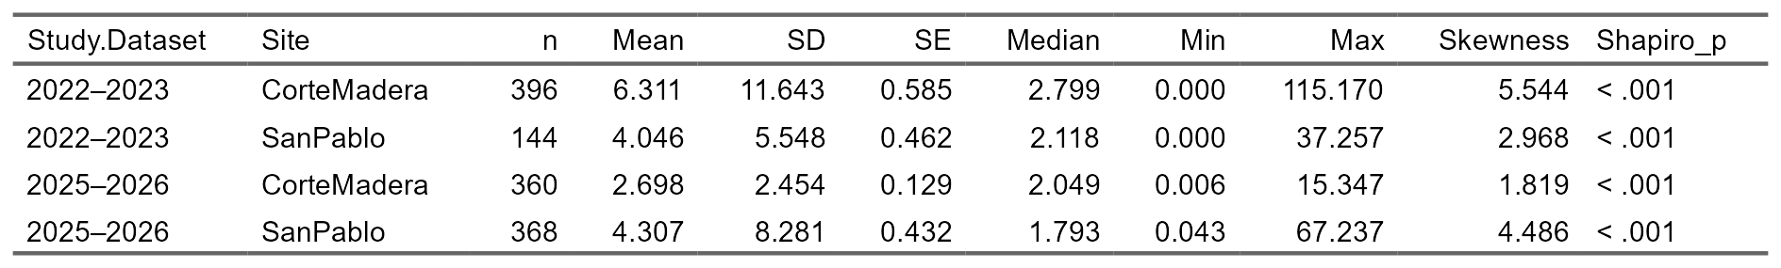

c. Seasonal Context Between Years Measured of 2022-2023 vs. 2025-2026 (Visualization)
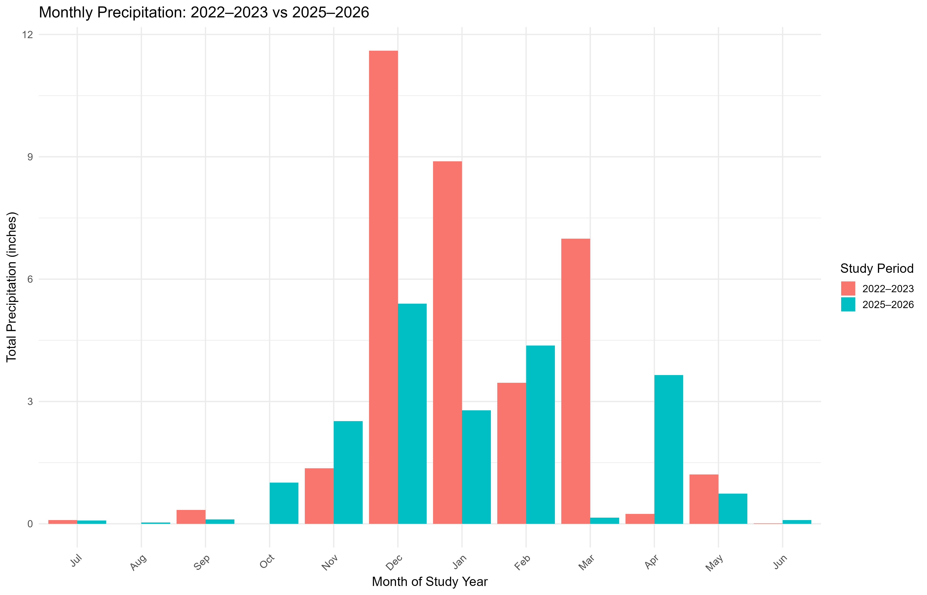

3.3 Sediment Deposition in Relation to Intra-Marsh Geomorphic Factors

a. LASSO Regression Analysis of Intra-Marsh Factors (Visualization)
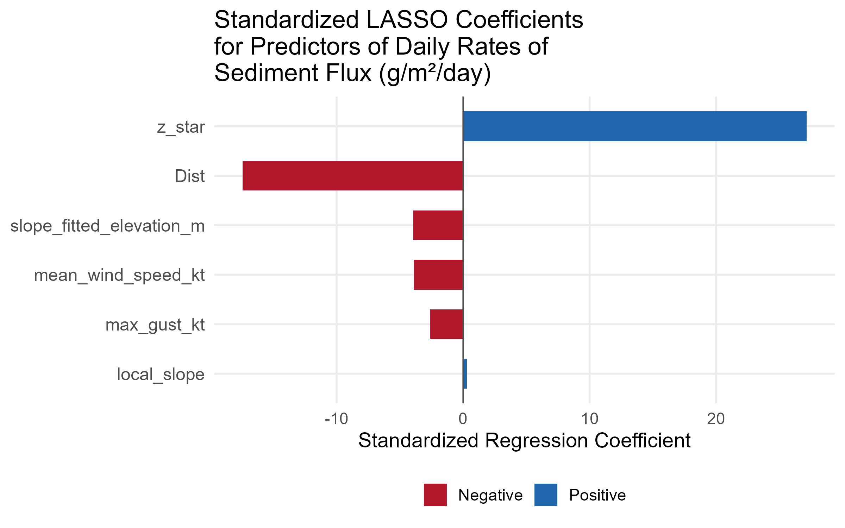

a. Site-Specific Differences Observed Based on Locations-Buck’s Landing and Corte Madera (Visualization)
*I recognize that these might be moreso part of the Discussion and not the results
Main point is to demonstrate how two marshes of similar side of the bay (East Facing) similar comparison on z star still have differences between transects as it relates to Flux measured.
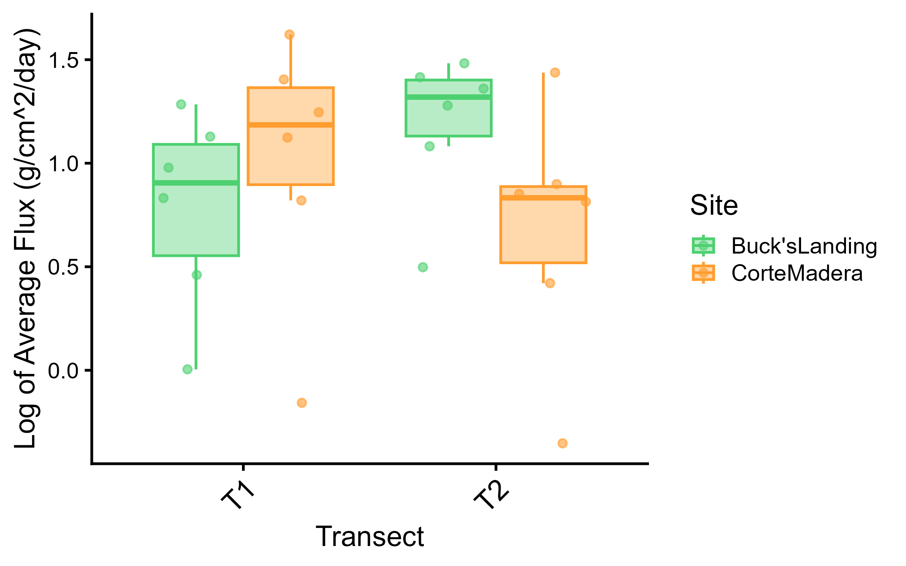

b. Site-Specific Differences Observed Based on Within the Same Marsh Between Bay and Channel Transects in 2022-2023 (Visualization)
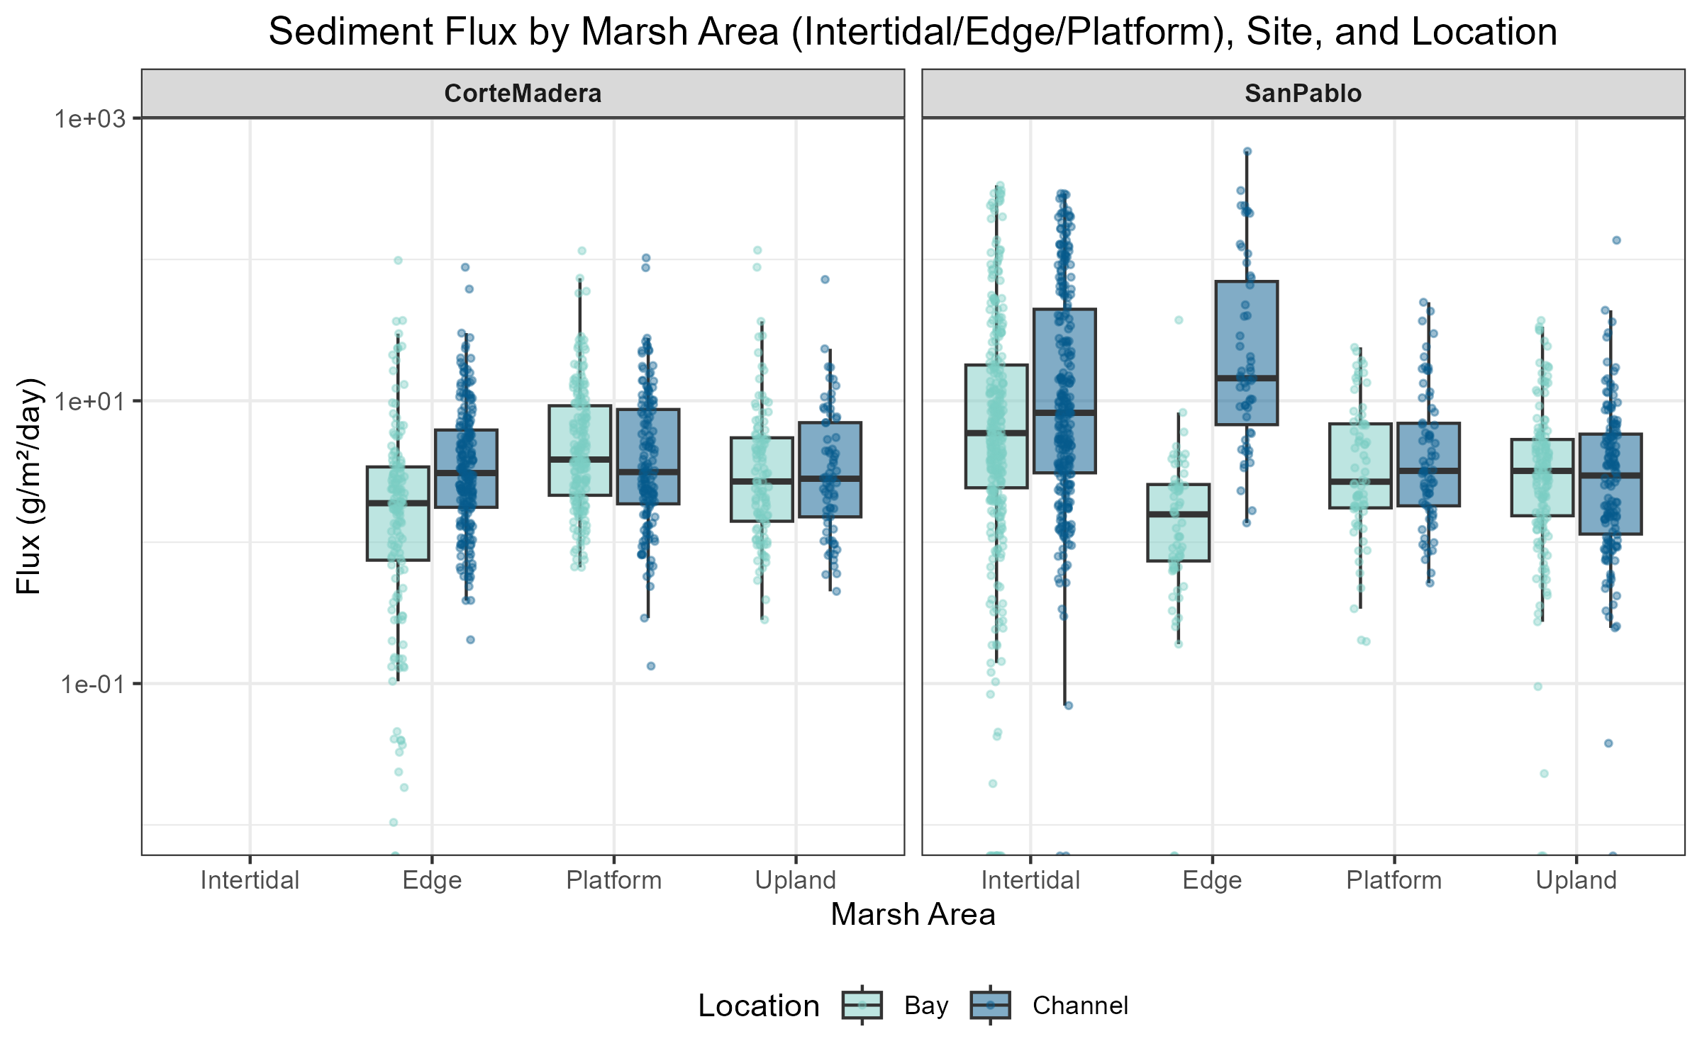

c. Site-Specific Differences Observed in San Pablo Specifically in the Intertidal Marsh Area Across Months in 2022-2023 (Visualization)
